The title

Presenting author ¹, Second author ²,

¹Affiliation 1, ²Affiliation 2,

Abstract PDF instructions:
- One page (A4), including text, figures and references list, with page margins of 25 mm all around
- The abstract text (justified font, Arial (10 points).
- Maximum 250 words, not exceeding 2000 characters
- Acknowledgement may be inserted as the last paragraph of the text body.
- References should be indicated in the text in brackets and listed at the end of the paper
[1] Author(s), Journal Name, issue, page, (year)
(e.g.: Wang et al., 2019).

. 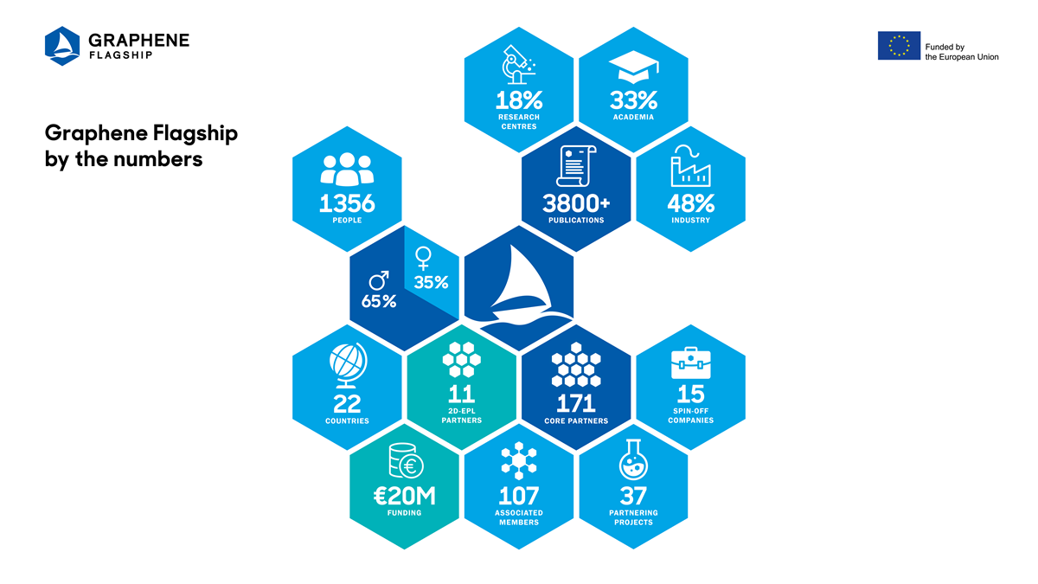
Fig. 1. Figure caption

