The title

Presenting author 1, Second author 2,

1Affiliation 1, 2Affiliation 2,
Abstract PDF instructions:
- One page (A4), including text, figures and references list, with page margins of 25 mm all around
- The abstract text (justified font, Arial (10 points).
- Maximum 250 words, not exceeding 2000 characters
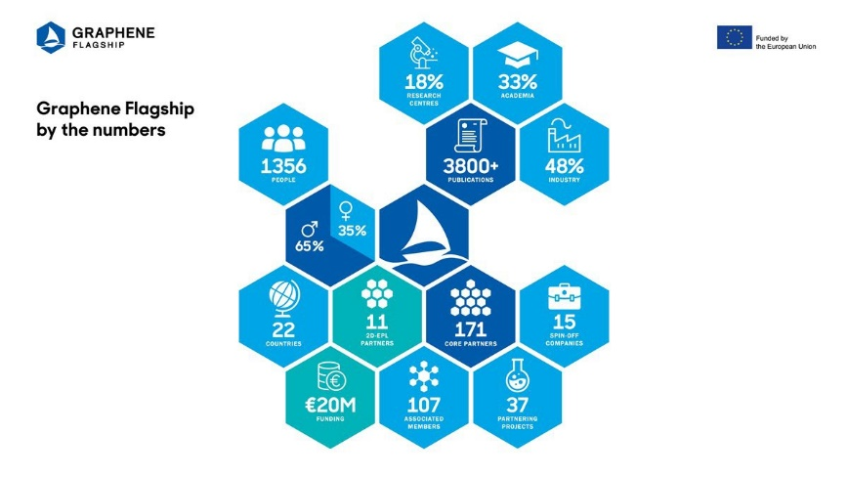
- Acknowledgement may be inserted as the last paragraph of the text body.
- References should be indicated in the text in brackets and listed at the end of the paper
  - Author(s), Journal Name, issue, page, (year) (e.g.: Wang et al., 2009).

Fig. 1. Figure caption

www.graphene-flagship.eu

